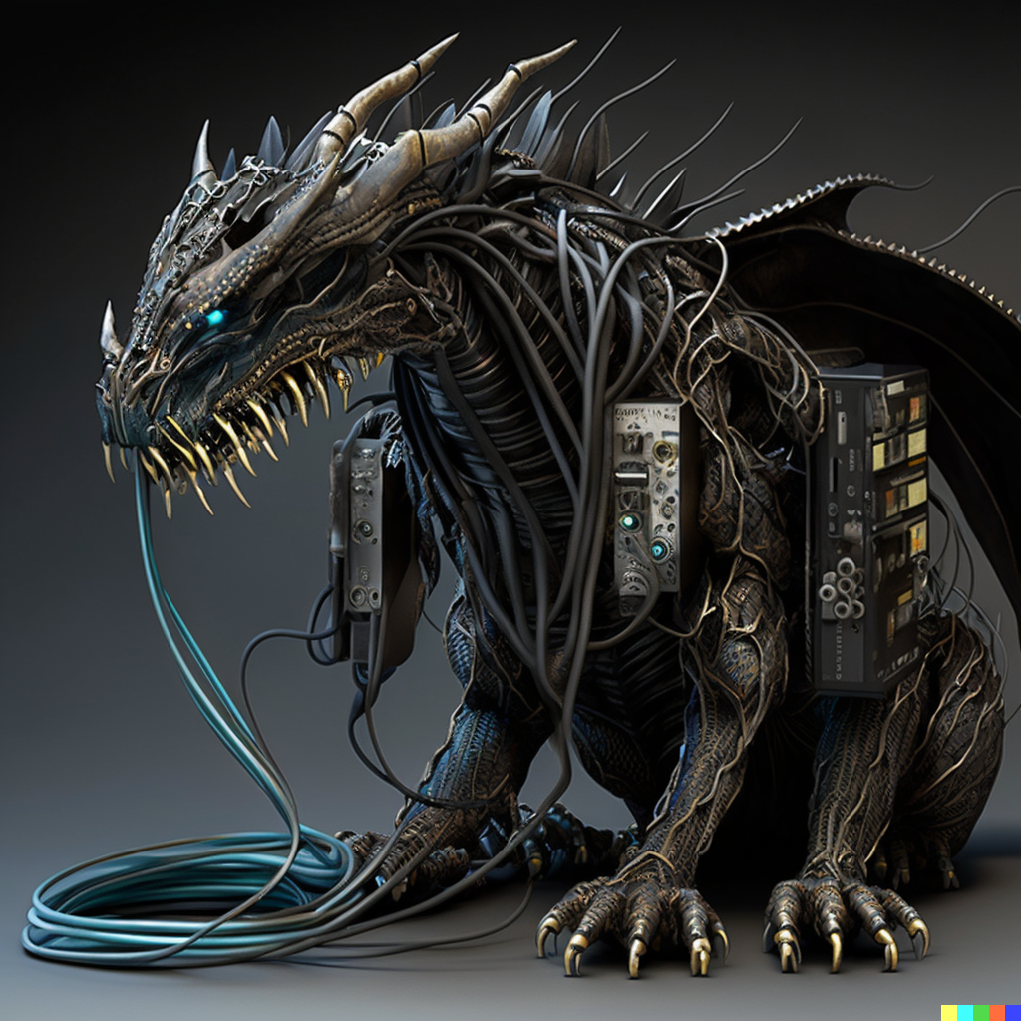

**As Long as We Have Each Other, We Will Never Run Out of Problems**

**Genres**  
  
  
  
Action RPG